Can you identify invertebrates around your home? Head outside and answer the questions below to see what types live near you!

No

Yes

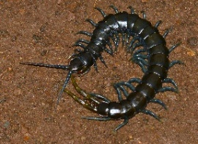

No

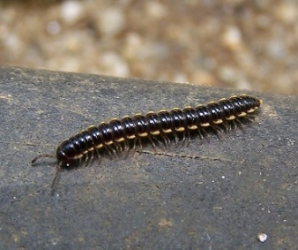

Millipede

Yes

No

Yes

Do you see legs?

Are there 3 legs on each side?

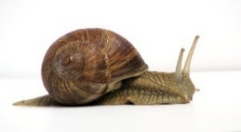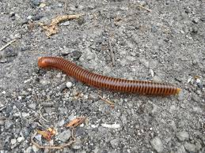

No

Yes

Do you see a shell?

No

Yes

Does it have a long, tube-like body with different sections?

Great work! Snails and slugs aren’t bugs. They’re gastropods in the mollusk family.

Snail

Slug

Worm

All worms have no limbs and no eyes.

No



Nice job, you’ve found an insect! All insects have 6 legs, three body parts, and antennae.

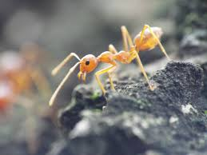

Yes

Yes

Are there 8 legs?

No

Does it have a stocky, oval-shaped body?

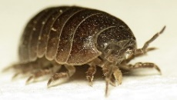

Woodlouse

These crustaceans are sometimes called roly-polies!



Yes

No

Does it have 2 body segments?

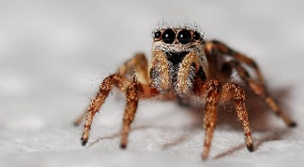

Spider

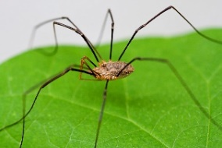

Harvestman

Spiders and harvestmen or daddy long-legs are both in the class *Arachnida.*



Are there long antennae on the head?

Centipede



Although they look similar, these invertebrates aren’t related.

Red Ant